Name:Naga Madhuri .K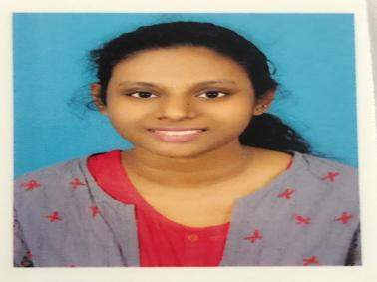

Mail id: [madhurireddy1477@gmail.com](mailto:madhurireddy1477@gmail.com)

Contact details:7013616132

Aim: To work in an organization where I can contribute my learnings with the best of my ability and to grow as a better individual by learning more,taking up challenges.

## Educational Qualifications:

Course Institution Board/University Year of completion percentage

B.Tec(ECE) G.Pullaih college of engineering and technology JNTUA 2022/Pursuing 60

Intermediate Sri chaithanya college,Kurnool State board 2018 8.2

S.s.c Sri chaithanya school,Kurnool. State board 2016 8.2

Professional interest :

Internships: worked for a months as a business development intern at Tamasha which is a startup by IIT bombay alumni

Moved as a Hr intern at Tamasha.live

Campus ambassdor at collegedunia,tutudude.

Clubs/Organisations: Toastmasters international oganisation,.hanuma vihari foundation

Programming knowledge: phython, system testing

Extra skills: Public speaking, content writer, co author.

Strength: much better communication skills and public speaking skills, leadership qualities, Team management. Negotiation skiils, critical thinking, successful collaboration.

Hobbies: working out, reading books.

Project details:Humidity sensor using Arduino

Languages known: Telugu, Fluent English, Beginner at French

## Accomplishments or participations:

Co author of book flying minds.

Participated and canvassed as a PR in Master Orator Championship which is a public speaking platform, part of Toastmasters international in the year 2018,2019

Officially, member of toastmasters international since 2020

Participated ND

Received triple crown award and pathway star award in toastmasters international

Completed a pathway of 5 levels in motivational strategies.

Volunteered in marketing and registration team of eloquence which is biggest annual conference

Served as a club officer treasurer in TI

Gone through English learning modules in udemy

Participated in poster presentation in jana vignana yojana in 2019

Attended a virtual workshop at learnathon about emotional intelligence.

Completed 1 month internship at Tamasha which is a gaming startup by alumins of IIT Mumbai as a business development intern

Declaration: I hereby declare that above mentioned information is truely with my knowledge and belief.